**1 a)** What is meant by energy dissipation? (1)

**b)** What happens to the energy that is dissipated? (1)

**c)** A car is run on petrol. What sort of energy is stored in petrol? (1)

**d)** What are the two main things that the petrol in the car’s engine converted into? (2)

**e)** Name two design features of a car that can be used to reduce energy dissipation. (2)

**2** All aspects of modern life depend on energy resources. There are two main types of energy resource. These are renewable and non-renewable. Put the following resources into the table.

geothermal peat natural gas hydroelectricity solar energy coal

|  |  |
| --- | --- |
| Renewable | Non-renewable |
|  |  |
|  |  |
|  |  |
|  |  |

(6)

**3** There are many power stations that still burn fossil fuels to generate electricity.

Burning fossil fuels leads to increased levels of polluting gases.

**a)** Name the main gas created by burning fossil fuels. (1)

**b)** What effect are increasing levels of this gas having on the atmosphere? (2)

The diagram shows how much of this gas is produced when generating electricity in coal, oil and gas-burning power stations.

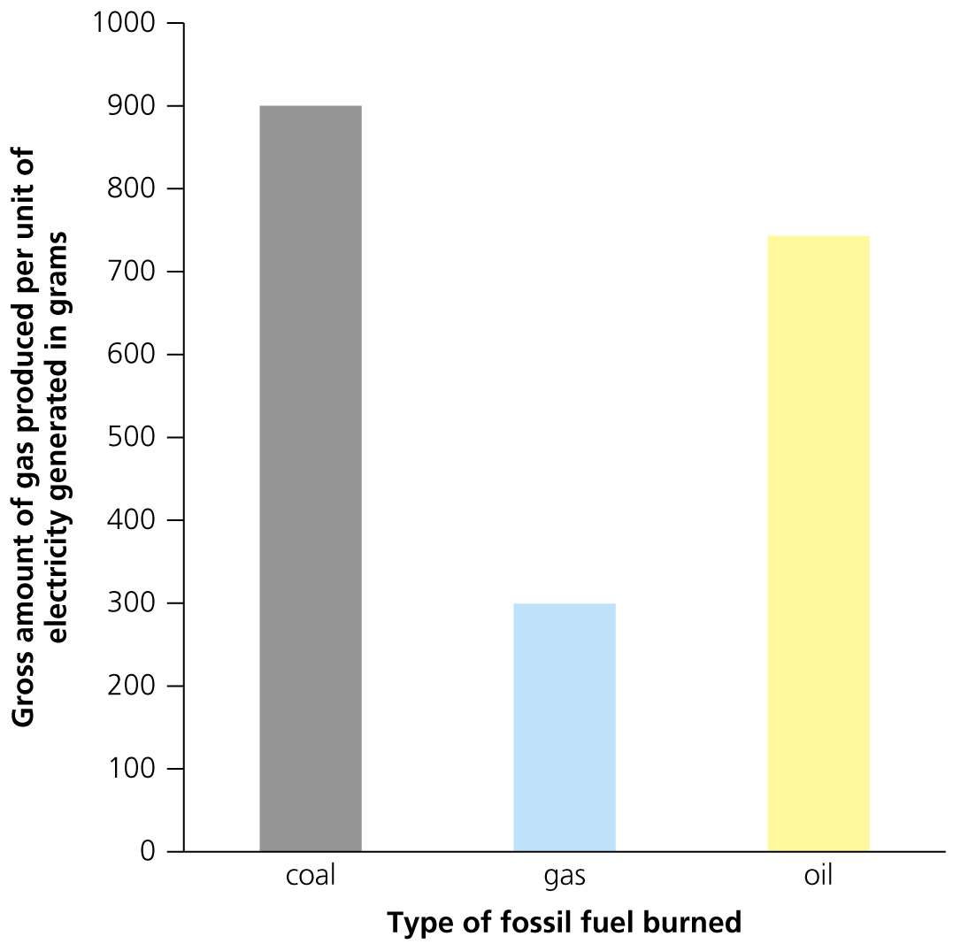

**a)** Why is the data presented in a bar chart and not a line graph? (1)

**b)** Which type of fossil fuel is the least harmful to the environment when burned? (1)

**c)** Biofuels can also be used to generate electricity. Give an example of a biofuel. (1)

**d)** Explain why biofuels are often described as carbon neutral. (3)

**4** Energy can be transferred in four different ways. Two of these are:

* mechanical work
* electrical work.

**a)** What are the other two energy transfers? (2)

The diagram shows the energy transfers in a torch.



**b)** Label the gaps in the diagram to show the energy stores in:

**i)** the battery

**ii)** the surroundings. (2)

**c)** Describe the energy transfers on the diagram at the points:

**i)** X (1)

**ii)** Y (2)

**5** Joe wants to test the energy released from three different fuels. He will test paraffin wax, ethanol and a firelighter. He sets up the following experiment.



**a)** Name two things that must Joe must measure and record before the experiment? (2)

**b)** He sets fire to the fuel and uses it to heat the water. After the fuel has completely burned, name two things must he now measure and record? (2)

**c)** What is the independent variable in this experiment? (1)

**d)** Name two control variables in this experiment. (2)

**e)** Suggest one precaution that Joe should take to minimise any hazards. (1)

The bar chart shows the rise in temperature for each of the fuels.

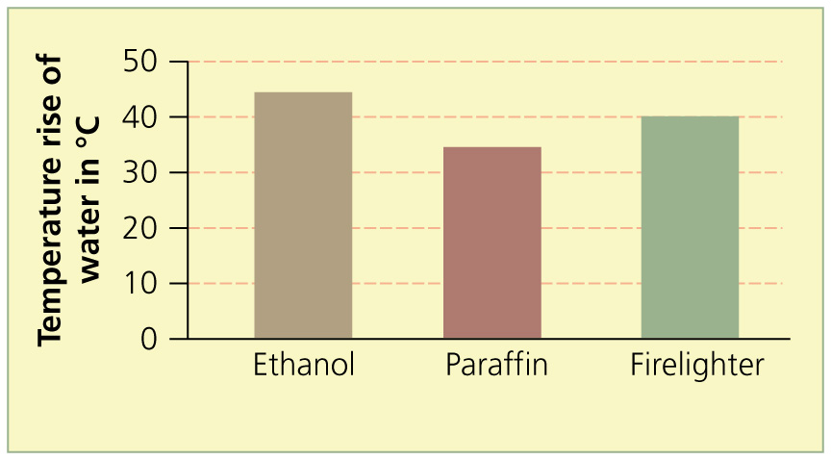

**f)** Which fuel released the greatest amount of heat? (1)

**g)** The specific heat capacity is the number of joules of energy required to raise the temperature of 1 g of water by 1 °C. The specific heat capacity of water is 4.2 J/g °C. The firelighter weighed 2.5 g, and it raised the temperature by 40 °C. How much energy did the firelighter release per gram? Show your working. (1 cm3 water weighs 1 g.) (3)

**h)** Give two reasons why the decrease in the chemical energy store of the firelighter is greater than the increase in the thermal energy store of the water. (2)

**6 a)** Fill in the gaps with the most appropriate word or words.

The proportion of energy that is usefully …………………….. into a process is called efficiency. An efficient system would transfer the ……………… proportion of the energy input into ……………… Many ………………… are designed to help improve efficiency. For example, when lifting heavy weights, a ………………… system could be used

Efficiency can be calculated using the equation:

efficiency =

Because efficiency is a ratio, there are no ………………………..

highest  machines  output  pulley  transferred  units    (6)

**b)** A motor is used to lift heavy objects in a warehouse. The electric motor is supplied with 300 W of power. It lifts up a wooden block which has a weight of 500 N. The block is pulled up 4 metres in 20 seconds. Calculate the efficiency of the motor. (3)

TOTAL = 52

**1 a)** Dissipation means to be spread out in all directions. (1)

**b)** Energy that is dissipated is lost to the surroundings. (1)

**c)** Chemical (1)

**d)** Power to drive the car forward and heat energy which is wasted (2)

Fuel-efficient cars dissipate less energy; streamlined cars reduce air resistance; lubrication of moving parts reduces friction. (2)

**2**

|  |  |
| --- | --- |
| Renewable | Non-renewable |
| geothermal | peat |
| hydroelectricity | natural gas |
| solar energy | coal |

(6)

**3 a)** Carbon dioxide. (1)

**b)** Greenhouse effect; warming up the Earth’s atmosphere; raising sea level (any suitable answer). (2)

**c)** The data is discrete or discontinous; there are no intermediate values. (1)

**d)** Gas (1)

**e)** Wood, methane, ethanol. (1)

**f)** Biofuels are derived from plants. Burning biofuels releases carbon dioxide but plants remove carbon dioxide from the atmosphere during photosynthesis. (3)

**4 a)** thermal; radiation (2)

**b)**

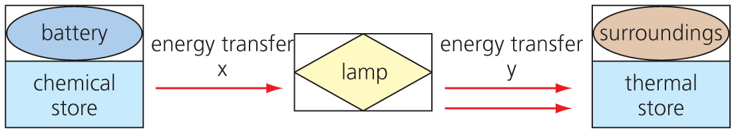

(1 mark each in the boxes = 2)

**c)** **i)** X = electrical work (1)

**ii)** Y = heat and radiation (2)

**5 a)** The temperature of the water; the mass of the fuel; the volume of water. (2)

**b)** The temperature of the water; the mass of fuel residue (2)

**c)** The type of fuel. (1)

**d)** The volume of water; the mass of fuel the block; the initial temperature of water. (2)

**e)** e.g. safety glasses to be worn; gloves; fire extinguisher available. (1)

**f)** Ethanol (1)

**g)**  (3)

**h)** The apparatus not being insulated; energy lost heating the beaker; energy lost to atmosphere; chemical energy lost lighting the fuel block. (2)

**6 a)** The proportion of energy that is usefully **transferred** into a process is called the efficiency. An efficient system would transfer the **highest** proportion of the energy input into useful **output.** Many **machines** are designed to help improve efficiency. For example, when lifting heavy weights, a **pulley** system could be used.

Efficiency can be calculated using the equation

efficiency =

Because efficiency is a ratio, there are no **units.** (6)

**b)** Power required to lift block = = 100 W

power supplied to motor = 300 W

efficiency =  (3)

TOTAL = 52